# Question 01

## Code

clc

clear all

close all

char=input('enter a character:','s');

x=linspace(-2*pi,2*pi,50);

y=sin(x);

if char=='b'

plot(x,y,'*','Color','b')

else

plot(x,y,'+','Color','k')

end

grid on

title('Q01')

xlabel('x')

ylabel ('sin (x)')

## Output



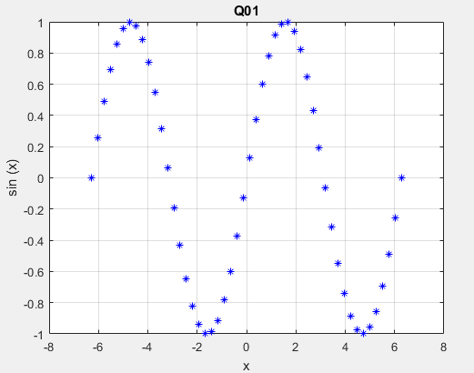

# Question 02

## Code

clc

clear all

speed=input('enter wind speed in mph:');

if speed< 39

disp('torpical depression')

elseif speed >=40 && speed <=74

disp('torpical storm')

elseif speed>=75

disp('hurricane')

end

## Output

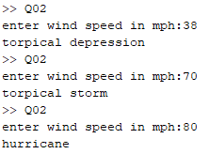

# Question 03

## Code

clc

clear all

for i=2.5:.2:4.7

disp(num2str(i))

end

## Output



# Question 04

## Code

x=0;

while x<10

x

x=x+1;

end

## Output

For the x=10 loop terminate and loop repeat for x=9.